HILLY FIELDS FOOTBALL CLUB
SEASON 23: 1989-90
Veterans Friendly
P W D L F A
Sutcliffe 1 1 0 0 3 2

Apps Gls
Adrian Bennett 1 0
Colin Chandler 1 0
Steve Chitty 1 0
Keith Foster 1 0
Len Franklin 1 1
Larry Garnham 1 0
Chris Green 1 0
Ray Griffin 1 0
Malcolm Hill 1 0
Tom Pollard 1 0
Frank Ryan 1 0
Kevin Shearer 1 2
Chris Yusuf 1 0

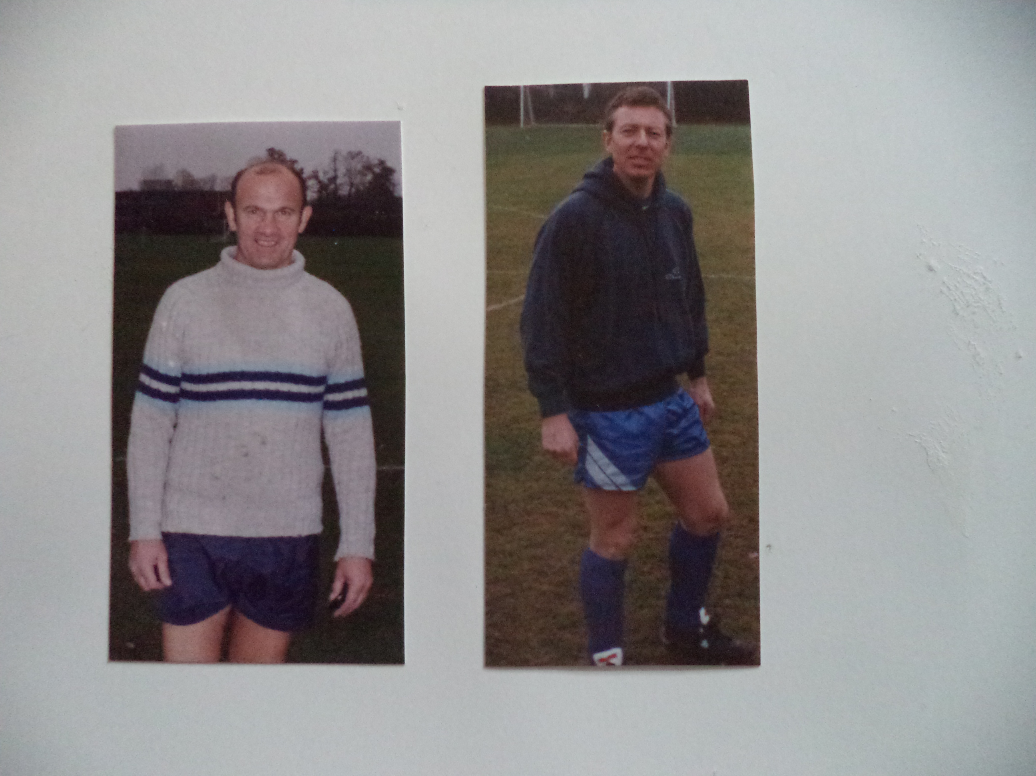
Adrian Bennett Malcolm Hill

